The EARTH SCHOOL
Endowment for World Orphans
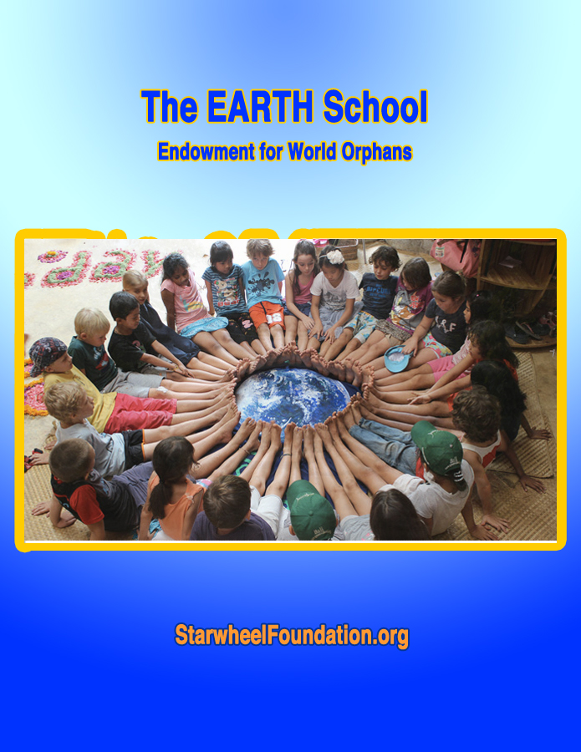

A special reach-out project dear to Aya is to create an endowment fund to provide 1-2 years of full residency and tuition for orphans from around the world. Why orphans? Deprived from the loving start of a family, and confronted with adversity, orphans can develop special qualities of resiliency, commitment and inner wisdom if they receive appropriate support. According to UNICEF, there are roughly 153 million orphans in the world; each day, an estimated 5,700 more children become orphans… and the number is fast growing.
We want to encourage world orphans to create the best life they can, for themselves and for all others – and to offer orphans the chance of experiencing a family, at least as a community.

• The Vision - An international committee would select candidates from all the world’s nations. Currently, the United Nations Organization recognizes a total of 197 countries. This includes 193 member countries, 2 U. N.
observers (Vatican and Palestine), and Taiwan and Kosovo, regarded as self-governed territories. The list is sometimes extended to 215 (potential) countries.
The vision of the EWO is to offer a scholarship to 1-2 orphan kid from each country. That kid would go back after 1-2 years at the Earth School and share her/his experience with their home school orphanage. Another kid would then be selected as an ambassador to the Earth School for the next residency cycle.
Just imagine the vast spectrum of possibilities: kids from ALL nations living and learning together for 1-2 years, in a Costa Rica environment providing the best of tropical nature and the best of creative, eco-global, non-competitive education.

• A Direct Exposure to the physical type, language, customs & traditions, history & culture, music-dance-chants, skills and wisdom of each of these nations comprising the abstract entity we call “humanity”.
Each “ambassador orphan” would be asked to make a presentation of their country’s unique character and contribution to the world at large. This would bring home for each kid a personal, emotional experience of each country in the form and the presence of a friend or fellow student.
• A Global Immersion and Larger Perspective of Life on planet Earth. By the international nature of the student population, the kids would be constantly perceiving situations, as well as feeling and thinking, in terms of the totality of humanity, rather than to continue the nation-centric old conditionings. The evolution and future of humanity would be the point of focus, rather than fighting for the superiority of a race, a culture or a country. The old syndrome of competitivity would rapidly fade in the face of the exciting variety and bubbling richness of so many modulations of what it is to be “human”. Comparison and judgments would be replaced by collaboration, cooperation and co-creation. The joys of team-work, team-play and life celebration would blossom, for the greater benefit of world peace.

• The Very Definition of a “Human Being” would shift to an Earth dweller or galactic citizen. And all subjects studied and practiced would have some multi-national overview, as well as a cosmic context in terms of the grand scheme of Life and Consciousness. Latest astrophysics is listing some 2 trillion galaxies and we live on a planet orbiting one of the 200 billion stars of a single galaxy, the Milky Way. That’s the kind of context expansion that would be possible for the kids at the Earth School.

We are inviting feedback, contributions and donations
that could make this EWO project more of a manifested reality.

Kindly contact
Aya@starwheels.com
http://www.StarwheelFoundation.org
928-300-7971

